阅读日期：

发表日期：20071129

发表杂志：

影响因子：

平均影响因子：

标签：

|  |  |
| --- | --- |
| 文章名 DrugBank: a knowledgebase for drugs, drug actions and drug targets | |
| 中文译名 | 药物库:药物、药物作用和药物目标的知识库 |
| 网址 | http://www.drugbank.ca |
| 关键词 |  |
| 摘要 | DrugBank is a richly annotated resource that combines detailed drug data with comprehensive drug target and drug action information. Since its first release in 2006, DrugBank has been widely used to facilitate in silico drug target discovery, drug design, drug docking or screening, drug metabolism prediction, drug interaction prediction and general pharmaceutical education. The latest version of DrugBank (release 2.0) has been expanded significantly over the previous release. With 4900 drug entries, it now contains 60% more FDA-approved small molecule and biotech drugs including 10% more ‘experimental’ drugs. Significantly, more protein target data has also been added to the database, with the latest version of DrugBank containing three times as many non-redundant protein or drug target sequences as before (1565 versus 524). Each DrugCard entry now contains more than 100 data fields with half of the information being devoted to drug/chemical data and the other half devoted to pharmacological, pharmacogenomic and molecular biological data. A number of new data fields, including food–drug interactions, drug–drug interactions and experimental ADME data have been added in response to numerous user requests. DrugBank has also significantly improved the power and simplicity of its structure query and text query searches. DrugBank is available at http://www.drugbank.ca |
| 启发 | 药物有两种类型：1临床药物，2化学分子药物。  临床药物的数据库有一些，但那些数据库主要针对药剂、新陈代谢、适应症状  我们需要的一些来自化学方面的数据库，包括：  TTD (3), the Druggable Genome database (4),KEGG (5), PubChem (6) and ChEBI (7) |
| 摘录 | 1,Drugbank有很多贡献: Since its initial release, DrugBank has been used in a wide range of applications including in silico drug discovery (9), drug ‘rejuvenation’ (10), drug docking or screening (11), drug metabolism prediction (12), drug target prediction (13) and general pharmaceutical education.  2，Drugbank和pdb有联系：In addition, DrugBank’s collection of experimental or unapproved drugs (or drug-like) compounds, which is primarily derived from the PDB’s Ligand database, has expanded to include 3116 compounds, compared to 2896 compounds in the first release.  药物和配合基的数据大概有3116条。  3，生僻的药物和违禁的药物也加入了。  4,Drugtarget增加了，目前有1565个drug target.  这些药物靶点多数由PolySearch提供。(http://wishart.biology.ualberta.ca/polysearch/)  5,All of these newly identified protein targets are fully referenced to an average of four PubMed citations each.所有的这些新确定的蛋白质靶点都有全面的参考，平均上有4个PubMed的注释。  6,药物靶点是大家关注的事情，除了TTD，还有4个人分别提出了一些药物靶点，  7我们还收集了很多drugtarget:  Several other drug target lists have been compiled or presented including those in TTD (3), as well as others by  1，Hopkins et al. (15), 248 protein targets (out of 399 molecular targets)  2，Drews and Ryser (16), 483 molecular targets  3，Imming et al. (17)，218 molecular targets  4，Overington et al. (18). 324 molecular targets  These report 578 molecular targets (out of 1512 total targets including disease and organism targets),  8,DB的数据比他们多3-4倍，原因是：收集了很多小分子，2倍左右；生物技术制药和保健品药，每个药有5-10个靶向蛋白；别的数据库只列出主要靶点，而不是全部靶点；解释了许多药物靶点是由多个蛋白质子单元组成。  9，当新增drug target的时候，它的序号将大约上接近和它“物理效果相近”或它的“治疗效果相近”  10它和生物数据库有链接，也和药物数据库有链接，最近又多了更多的链接。和维基百科也有链接。  11，Drugbank 包含107个fields（名称、类别等）.若是peptide/protein是其中使用的SwissProt的name。  12，PolySearch用来寻找drugs, drug targets, drug metabolites, diseases, proteins and drug–protein interactions.相关信息。这个工具也需要关注一下： |
| 相关论文 | **【3-7】有关分子的数据库：**  **3【药物作用靶点数据库】. Chen,X., Ji,Z.L. and Chen,Y.Z. (2002) TTD: therapeutic target**  **database. Nucleic Acids Res., 30, 412–415.**  **4【一种更新的数据库】. Russ,A.P. and Lampel,S. (2005) The druggable genome: an update.**  **Drug Discov. Today, 10, 1607–1610.**  **5【**从基因组学到化学基因组学:KEGG核酸研究的新进展。**】. Kanehisa,M., Goto,S., Hattori,M., Aoki-Kinoshita,K.F., Itoh,M.,**  **Kawashima,S., Katayama,T., Araki,M. and Hirakawa,M. (2006)**  **From genomics to chemical genomics: new developments in KEGG.**  **Nucleic Acids Res., 34 (Database issue), D354–D357.**  **6【**国家生物技术信息中心数据库资源。**】. Wheeler,D.L., Barrett,T., Benson,D.A., Bryant,S.H., Canese,K.,**  **Chetvernin,V., Church,D.M., DiCuccio,M., Edgar,R. et al. (2007)**  **Database resources of the National Center for Biotechnology**  **Information. Nucleic Acids Res., 35 (Database issue), D5–D12.**  **7【**欧洲生物信息学研究所的数据资源:系统生物学核酸资源。**】. Brooksbank,C., Cameron,G. and Thornton,J. (2005) The European**  **Bioinformatics Institute’s data resources: towards systems biology.**  **Nucleic Acids Res., 33 (Database issue), D46–D53.**  **【大家怎么用Drugbank】:** 13. Wishart,D.S. (2007) Discovering drug targets through the web. Comp. Biochem. Physiol. D, 2, 9–17 |

需要做的：

找到drugbank 中和PDB数据库有联系的配合基数据。他们是什么样的？能不能用？是准确到位点的吗？

读TTD论文

看PolySearch工具

总结：看起来很好很全面的数据库。希望以后可以有机会能了解或者参与到这样的工作当中去。

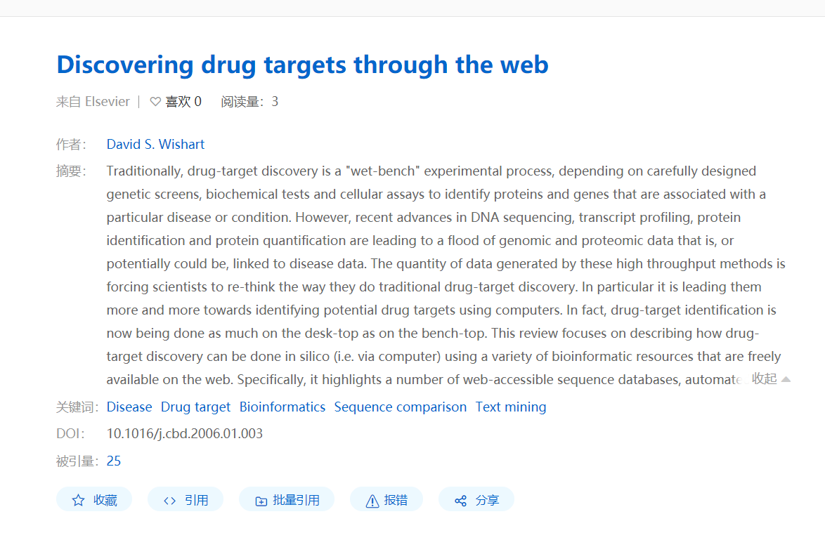

没找到文章的一个论文